**Kozy Eats.lv Domain**

Functionality + Design Features (Domain):

1. Header media: full-size video
2. Centered Logo
3. Column: One Column Menu Bar  
   (Menu, Reservation, News, Pastry, Contacts, etc.)
4. About Us Paragraph: w/ “About Us” button
5. Menu Preview (display of new or seasonal menu items): w/ “Full Menu” button
6. About our food (local produce; coffee; other ingredients/companies): implemented image-link to the companies’ page (offer *vice versa* marketing opportunities for the companies we support) (OPTIONAL)
7. Reviews – Google Reviews Widget
8. Social Media (IG post integration)
9. “Visit us”: image of Kozy Eats interior
10. Contacts (Google maps widget)

Media:

Photography of food / interior / exterior

Video of food and interior / exterior

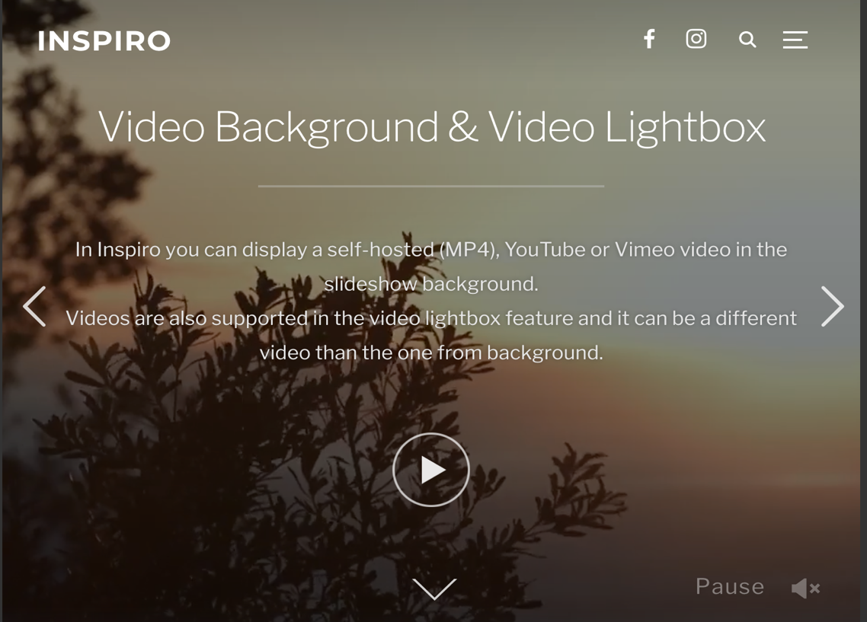

About Us

**What’s on our plate (local produce, about the ingredients we use, etc.)**

**Menu Preview (display of seasonal or new menu items)**

**AND/OR**

**Menu Preview - display of new or seasonal menu items**

**Reviews**

“Testimonial…”

- Customer

How was Your Experience?

**Social Media (linked to FB and IG)**

**Visit Us (view of the place)**

**Contacts**

**Email + Phone + Address   
  
Location displayed via Google Maps (widget)**

Template ideas:

<https://wordpress.com/theme/twentyseventeen>

<https://wordpress.com/theme/rockfield>

<https://bit.ly/3iLmqBu>

<https://wordpress.org/themes/catch-foodmania/>